Margot Smeenge
Secretariaat
Meeuwenweg 9
7938 PR Nieuw Balinge
fac@schapendoes.nl

Cecilia Wahlstedt,
Hövdingavägen 7
SE-236 61 Höllviken
Sweden

Nieuw Balinge, 28-02-2015

INVENTARISATION

Dear mrs Wahlstedt,

Your Schapendoes: TWINFLOWERS EL DIVO VAN LEILE SE 32728/2013

was assessed on 22-02-2015 in Bö Norway by Anne-Cathrine Unelsröd.

In this respect, the breeding committee (FAC) has assessed its suitablility to contribute towards the advancement of the breed.

Result: SUITABLE

If your dog is qualified for breeding* we assume that without notification to the contrary, he may be placed on the list of breeding male dogs.

On behalf of the breeding committee,

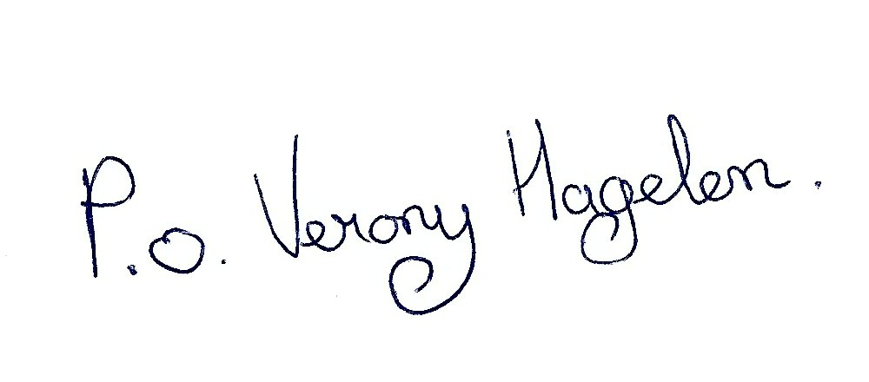
Margot Smeenge

A dog is qualified to breed (according to Dutch rules) if either:
- At a maximum of two inventories it is assessed to be “suitable to contribute to the advancement of the breed”. These inventories have to be done by two different judges qualified for the breed and trained in the Netherlands. The dog must be at least 15 months old and there must be at least 6 months between the two inventories, unless the dog is older than 24 months.
- Or, if it has been assessed at an inventory to be “suitable to contribute to the advancement of the breed” and also has been awarded the qualification of Very Good or Excellent at least twice at a club match organized by the Schapendoes Club or at a CAC/CACIB show, whereby the qualifications must be awarded by different judges qualified for the breed and trained in the Netherlands. Furthermore, at least one of these show qualifications must have been awarded when the dog was 21 months or or older.

